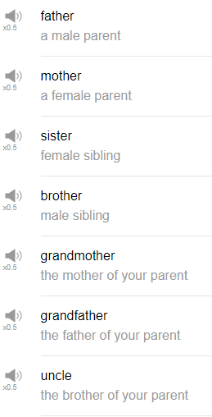

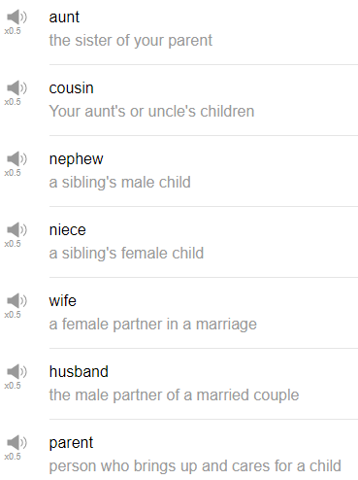

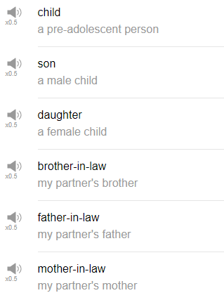

|  |
| --- |
| Today, where are we gonna go today? We've been to the piscina, we've been to the playa. Bi-biblio... library, vamos a la biblioteca. |
| Hi, everybody, my name is Alisha. Welcome back to Top Words. Today we're going to be talking about 20 Must-Know Family Words. So let's go! |
| 1. Mother |
| Mother is the person who gave birth to you, mother. You can say mom, mother, mom, mama mummy. |
| “My mother has amazing cooking!” it's true! |
| 2. Father |
| Father is the person who did not give birth to you but who helped make you happen. So we say father, dad, daddy, pa, pop. |
| “My father is a very level-headed person.” that's also true. |
| 3. Sister |
| Sister is a female sibling, so my brother might say “I have an older sister.” Anyone who is a female sibling, or someone you can use this for friends that you feel very very close to, like, “she's like my sister.” that's fine as well. |
| 4. Brother |
| We sometimes use “bro” for this. I would say “I have a younger brother.” |
| Like sister, you can use brother for any male that you feel is similar to a brother; someone you feel very close to. So “He's like a brother to me” or “You're like my brother.” |
| 5. Grandmother |
| When you put “grand” plus something else, it means the next generation or the previous generation, so you have your mother and father, in this case grandmother means your mother or your father's mother. It can be either of them, so grandmother. |
| “My grandmother was born a long time ago.” |
| 6. Grandfather |
| Grandfathers are just like grandmother, your mother or your father's father is your grandfather. |
| “My grandfather liked to play tennis” That's true. |
| 7. Uncle |
| Your uncle is either your mother or your father's brother, someone directly related to one of your parents who is a man is your uncle. |
| “My uncle is very good with woodworking.” Also true. |
| 8. Aunt |
| You might also hear aunt, both of them are correct. You can say aunt or aunt; an aunt or an aunt is your mother or your father's female sibling. |
| “One of my aunts gave me a stamp collection when I was a little kid.” That's also true. |
| 9. Cousin |
| Cousin is your aunt or uncle's children, it can be on any side, so typically these people are of the same generation as you, not always, but cousins are generally about the same age, at least in my family, they are. |
| “It's really fun to see all my cousins at family barbecues.” |
| 10. Nephew |
| A nephew is a sibling’s male child. So if you have a brother or a sister and they have children, any male children, are your nephews. Nephews. |
| “I don't have any nephews.” |
| 11. Niece |
| Niece, so your brother or your sister’s female children, any female children they have. You can say “She's my niece” or “I have two nieces, how many nieces do you have” or “I have a lot of nieces.” |
| 12. Wife |
| So this is a female partner that you are married to. “She is my wife” or “how is your wife?” |
| Wife is only used when you are married to that person. |
| 13. Husband |
| Husband is a male that someone is married to. So “how is your husband?”, “this is my husband.” |
| Again, husband is only used when you are married to that person. |
| 14. Parent |
| Parent is typically used generally for a mother or a father, like “I'm a parent”, “he is my parent”, “she is my parent.” It's often used in the plural “they are my parents,” “these are my parents,” “my parents are home,” “my parents are not at home.” |
| But you can also use parent to describe someone who raised you, so maybe your biological mother or father did not raise you, but someone else like an aunt or an uncle, or perhaps a different figure in your community did raise you, you can say “she's like a parent to me” or “she had a parenting role in my life.” |
| 15. Child |
| Child is a small human, a small human is a child. It doesn't necessarily have to be of your family, like,if you're just at the park and you see kids running around you can say “ah! look at that child.” |
| You can use a child in the singular, but be careful, child changes in the plural form to children, so not ‘childs,’ but children. One child, two children. Please be careful, this has an irregular plural form. “Maybe I'll have a child someday.” |
| 16. Son |
| Son is a male child, a male offspring. “My uncle has a lot of sons.” That's not true. |
| 17. Daughter |
| A daughter is a female child. “I wonder if I will ever have a daughter.” |
| 18. Brother-in-law |
| So we use in-law to mean our married partner’s family members; not my brother but my partner's brother. “In-law” is used after any family member's position or family member’s title to show they belong to my partner's family originally, but now they're part of my extended family as well. |
| “I'm going out for drinks with my brother-in-law tomorrow night.” |
| 19. Father-in-law |
| So we have in-law here, meaning my partner's father. So “my father-in-law is very kind”. |
| 20. Mother-in-law |
| Mother-in-law, meaning my partner's mother. In a sentence, “my mother-in-law and I get along really well.” |
| And that's the end! So those are 20 Must-Know Family Words that you can use to talk about your family, your partner's family, and the families of the people around you. They're very useful so try them out. Thanks very much for watching this episode of Top Words, and we will see you again soon for more fun stuff. Thanks very much for watching, bye! |
| You're finding out all kinds of things |